JiBE - Office Automation Framework Document

Automation Framework User Manual

Version 1.0

Modification Log
Version # | Date (MM/DD/CCYY) | Modified By | Change/Update Details
1.0 |  | Manivelrajan | Initial Draft

Table of Contents

1. Introduction
2. Installation
3. Minimum System Requirements
4. Browser Support
5. Framework Folder Structure

1. Introduction

The automation framework for JiBE - Office has been developed in JAVA using Selenium Webdriver as the automation tool and TestNG framework.

Selenium Webdriver
Selenium Webdriver is part of a suite of tools from the Selenium project which allows one to write and execute automated web application UI tests in any programming language against any HTTP website using any mainstream JavaScript-enabled browser.
Selenium Webdriver runs on many different operating systems and can start an instance of different browsers, including Windows Internet Explorer, Mozilla Firefox, and Opera. Using Selenium Webdriver, one can run tests automatically as many times as you want. You can add conditional statements and iteration to tests, which can help if you want to run tests with a set of data.

TestNG
TestNG is a testing framework for Java Programming Language inspired by JUnit and NUnit that provides both a framework that makes writing tests, executing tests and analyzing results easy.

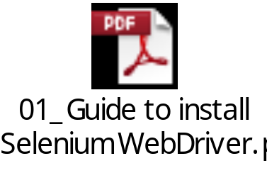2. Installation & Configurations:
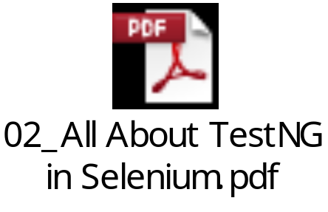

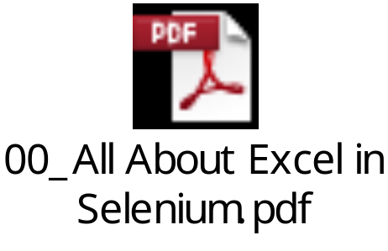

3. Test Environment

3.1 Minimum System Requirements
Operating System: 7.0
2 GB Ram, 60 GB HDD
Supporting Software (Pre- installed/configured): Browser, JRE,Eclipse,Selenium 2.0, TestNG,
3.3 Browser Support
1. Mozilla Firefox
(Needs to update when more browsers included)

4. Framework Folder Structure

The JiBE - Office Automation Framework comprises of following folder structure –

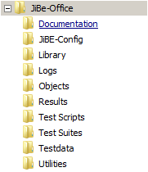

4.1 Documentation
All the documentation related to the “JiBE - Office Automation Framework” is stored within this folder. The document library will be incrementally updated as and when new scripts / functionality are added.
4.2 Library
This folder contains all the library files specific to the automation framework (independent of application under test)
4.3 Objects
This folder contains the Shared Test Object Repository files (Excel). Each object is identified by a “XPath” which uniquely identifies the object. The mapping of the Object with the corresponding “Xpath” is stored in these files.
4.4 JiBE-Config
This folder contains files (Excel) with all configurations associated to clients in JiBE - Office
4.5 Testdata
This folder contains the external Test Data source files (Excel). These Test Data files need to be created using pre-defined templates. These test data files are considered as inputs for the script file during execution.
4.6 Test Scripts
This folder contains all the Selenium Test Scripts and Methods (Java) files. Each Test Script can be identified as a Test Case.
4.7 Test Suites
This folder contains TestNG Test Suites (XML) files. A test suite is a collection of test cases intended to test a behavior or a set of behaviors of software program. In Test Suites, you can choose the test scripts and the order you wish to execute them.
4.8 Results
This folder contains the Test Result files that identify whether a Test Script has passed / failed.
4.9 Logs
This folder contains all the log files related to script execution. Each script file generates a log file during execution which can be used to identify execution success / failure. Screenshots captured during execution for specific scenarios are also stored within the folder.
4.10 Utilities
This folder contains utility files like “Delete Logs”, “Delete Results”, “Delete Screenshots” that can be used for cleanup of archived files within the framework folders.

